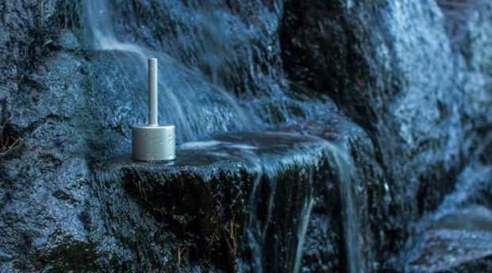

MISOGI-NO-KOKYU-HO – A weekend of cleansing the mind and body

February 10-12, 2022
House of Aikido, Zagreb, Croatia

Misogi-no-kokyu-ho is a form of cleansing the body-mind-spirit. It can be translated as “cleansing with breathing”.

During Misogi weekend, participants stay at the House of Aikido from Friday to Sunday, and sleep in sleeping bags or on the tatami. White or bright clothes are worn as a sign of external purity. Traditional Misogi food is consumed: miso soup, rice and boiled vegetables without salt.

Misogi consists of deep breathing exercises while loudly and strongly sounding out the following eight syllables:

TO - HO - KA - MI - E - MI - TA – ME

The practice is emotionally and physically intense. However, it is a unique opportunity to exceed one’s own ego, and self-inflicted limitations. Intense stimulation created by Misogi activates the primordial life force that resides deep in the lower abdomen area, allowing us to directly experience the root of our being.

The goal is to depart from oneself in order to find oneself…

SCHEDULE:

Friday |  | Saturday |  | Sunday
 |  | 5:00 | Waking hours, hygiene, tea | 5:00 | Waking hours, hygiene, tea
 |  | 6:00 | Introduction to Misogi | 6:00 | Misogi
 |  | 7:30 | Breakfast, tea | 7:30 | Breakfast & tea
 |  | 9:00 | Introduction to Misogi | 9:00 | Misogi
 |  | 10:30 | Tea
 |  | 10:45 | Introduction to Misogi
 |  | 12:15 | Tea & lunch | 12:00 | Lunch
 |  | 13:30 | Work assignments in the dojo & yard | 13:30 | Work assignments in the dojo & yard
 |  | 15:30 | Rest | 15:30 | Rest
 |  | 16:00 | Introduction to Misogi | 16:00 | Misogi
 |  | 17:30 | Tea
 |  | 17:45 | Misogi
19:00 | Arrival at the House of Aikido, preparations | 19:00 | Dinner | 19:00 | Dinner
20:00 | Dinner | 20:00 | Misogi | 20:00 | Misogi
21:00 | Tea, schedule  arrangements, rules of conduct, Q&A | 21:30 | Free-time and tea | 20:30 | Departure
22:00 | Bedtime | 22:00 | Bedtime |  | It is advisable to refrain from addictions till Monday

EQUIPMENT NEEDED:
- White or bright clothes, white kimono (gi), white socks (2-3 pairs)
- Water bottle, towel
- Working clothes

INSTRUCTOR:
Marijan Kudrna, Aikido teacher with 30 years of experience; Kinesitherapist and Kinesiologist

PRICE:
70 EUR per person

RULES OF CONDUCT:

- Minimal verbal communication.

We only converse on necessary issues, but other than that, we spend time in silence. When communication is necessary, we do it silently, so as to not disturb others. Chit-chat about politics, diseases, past events and future worries are not welcome. If those thoughts arise, keep them to yourself and let Misogi clear them out, as well as anxiety, fears and other entities we create ourselves. Same rule applies during meals. We can speak louder when we spend time outside of the dojo, during work assignments in the early afternoon.

- No communication with the outside world in the form of electronics and technology.

Cell phones, smart phones, laptops, head phones, music, or any such distraction is not allowed in the dojo. If an important phone call is necessary, it should be done outside and not in the near vicinity of the Misogi space. Talk to your loved ones and inform them that you will not be reachable and online for the duration of the two and a half days you will be spending in the dojo. Most of the communication we conduct must be internal, where there’s a lot of work to be done cleaning and tidying up. Books are allowed.

- Food and drinks: only sugar free tea, boiled vegetables without salt, rice and miso soup.

The body must be cleared of everything. Don’t bring snacks or candy with you. If you get into a crisis, you can put a few cloves in your mouth, it will keep you entertained and it’s good for your body.

- No alcohol, no cigarettes, no coffee.

This could be a real challenge for some, but it is necessary to completely clean our body and mind. Extreme conditions and lack of addictive substances will provide the best environment to face our own naked soul.

- Daily habits must be done in silence and in a manner that does not disturb other participants.

For example, don’t sing an excerpt from an opera while showering.

- Don’t judge and resent yourself and others for errors and mistakes if they occur during the day.

Just observe.

- Feel free to cry or laugh if the need appears.

In these circumstances we must be prepared for all sorts of reactions. If you feel a crisis arising, talk to the instructor.

REVIEWS OF PARTICIPANTS IN PREVOUS MISOGI RETREATS:

- “I am enjoying the wonderful peace and balance I am feeling within, since early morning! Thank you!”

- “My caffeine, nicotine and sugar addiction has somewhat blurred my vision, but the experience altogether kept me in a calm and pleasant state. Although it was physically demanding and I was slightly sleepy due to lack of coffee, my focus was rather sharp.

I am surprised by the post-misogi sensations: ever since Sunday evening I've been feeling such serenity and stability, no heaviness in dealing with daily obligations and relationships. I’m enjoying every moment and my layers of heavy emotions are just gone. Everything in me and around me is nicer, easier, more fluent and simpler. I’m so grateful!”

- “For the moment my brain isn’t overclocking… overthinking… overcooking… It’s somehow cool.”

- “It seems like misogi removes layers of discontent, fatigue, depression, inertia… and brings us back to our natural state. I couldn’t say that I’m peaceful… more like clear, fast, focused… Like an electric car.”

- “My head is much clearer, my thoughts more precise. My class this week has been incomparably more focused than before. The kids don’t even recognize me and are a bit scared of this change.”

- “It’s as if lying on the bottom of a clear river in complete serenity and watching your daily life pass by on the surface. The good and the less good are equal, you hold on to nothing.”

- “After 3 months of a severe block and creative crisis, I am finishing some paintings I’ve started long ago, and I just can’t stop.”

KONTAKT:

Marijan Kudrna
091 4900 008
manjoster@gmail.com

