GASSHUKU MISOGI at the source of ZRMANJA river
30.6. – 3.7.2022.

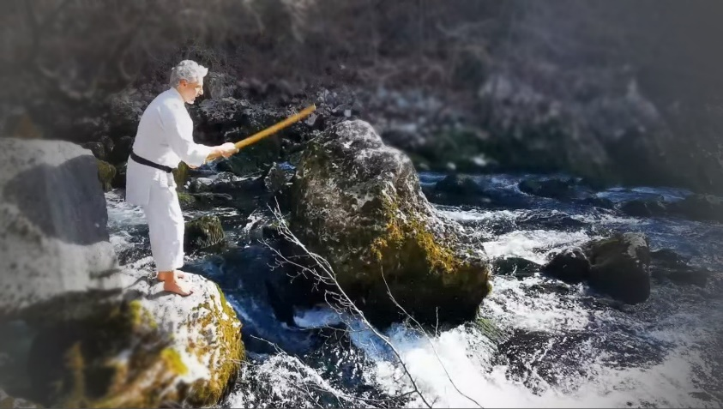 | Rediscover yourself at the source od Zrmanja river while clearing out your body and mind with a 3-day Misogi intensive.  Misogi will be performed with bokken and bell.

Accommodation:
Tents - bring your own tent and sleeping bag. It is possible to borrow a tent if necessary.

Equipment needed:
Misogi – white or bright clothes or gi, towel, matt to sit on
Walking/hiking clothes and shoes (not hiking boots)
Working clothes and shoes that can get dirty
Drinking and personal hygiene water

Meals are included in the price: rice/barley, fermented and boiled vegetables.

Rules of conduct:
- Bathing and personal hygiene in the river – please do not use conventional soaps, shower gels or toothpastes.
- We will be using a natural tolet in the forest – please do not use scented or coloured toilet paper or damp cloths.
- Minimal communicaton – we only speak when necessary, most of the time will be spent in silence. When communication is necessary, do it in a way that does not disturb other. Keep your thoughts to yourself and let misogi dispel all the anxiety and fears. Same rule applies during meals.
- No electronics and technology (laptops, head phones, music, or any other distraction). If a phone call is necessary, do it in a way that does not disturb others, distance yourself from the group and only engage for the lenght of transmitting required information.
- Prepare your loved ones for your unavailability for the days you will be spending at the retreat. Most of the focus of communicaiton should be inside of us where there is a lot of work to be done. Reading a book is allowed.
- We only consume water and sugar free tea, and fermented and boiled vegetables with rice and barley. Do not bring snacks or candy. If you must have something to chew on, you can use cloves. They are a good „cheat snack“ and they are good for your body (respiratory system and a natural antibiotic).
- No alcohol, coffee and cigarettes. This could be quite a challenge for some, but consider it an addition to misogi – a complete cleanse of the system. When reduced to extreme conditions, we can face our own stripped souls and see what's left.
- Daily habits must be performed in a manner that does not disturb others. For example, do not sing an opera during personal hygiene.
- If a mistake or error occurs, do not judge the person it happened to, especially if that person is you. Simply observe.
- If you feel the need to cry or laugh, feel free to do it. Nothing is unusual in conditions like these. If you feel a crisis coming on, talk to the instructor.

Instructor: Marijan Kudrna
Chef: Marko Pašalić / Logistics: Saša Folnegović

Price: 500kn/70€ (Advance payment till 15.6. : 200kn/30€)

Minimum of 8 persons is required, so please register in advance to: Marijan, 091 4900 008; manjoster@gmail.com

THURSDAY 30.6.  Arrival to the Zrmanja valley between 18 and 20h.  Preparation of tents and dinner. |  | SATURDAY 2.7.  5:30 Waking hours  6-7 Breafast and tea  7-9 Working tasks  10:30-13 Misogi  13-14 Lunch and tea | 14-14:30 Rest  14:30-17:30 Misogi  18:30-19:30 Dinner and tea  19:30-20:30 Misogi  20:30-22 Free time by the river
FRIDAY 1.7.  5:30 Waking hours  6-7 Breakfast and tea  7-9 Working tasks  10:30-13 Misogi | 13-14 Lunch and tea  14-14:30 Rest  14:30-17:30 Misogi  18:30-19:30 Dinner and tea  19:30-20:30 Misogi  20:30-22 Free time by the river | SUNDAY 3.7.  5:30 Waking hours  6-7 Breakfast and tea  8-10 Misogi  11-13 Lunch, departure

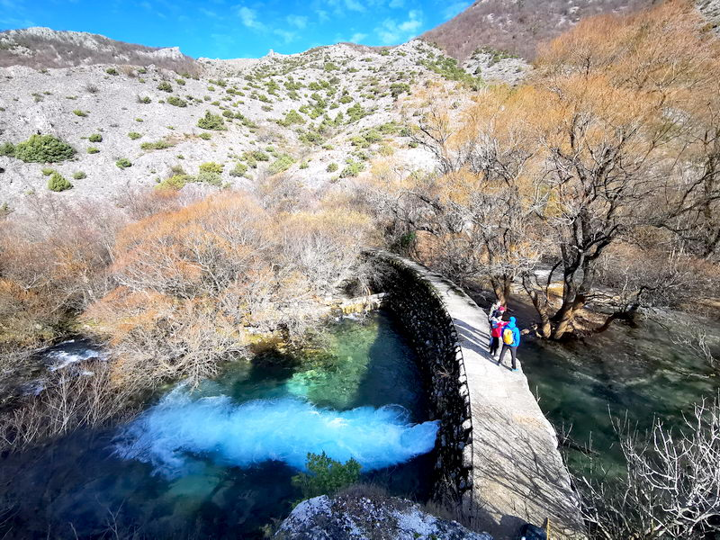 | 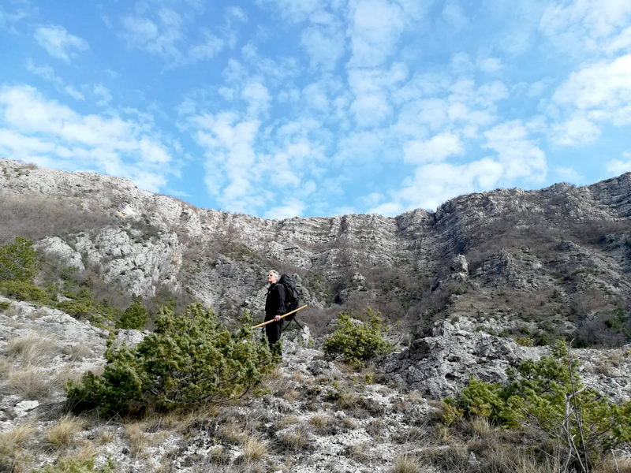
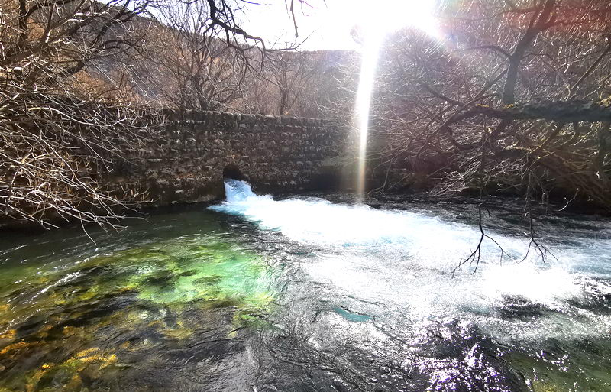 | 